93

Evaluation Report Template
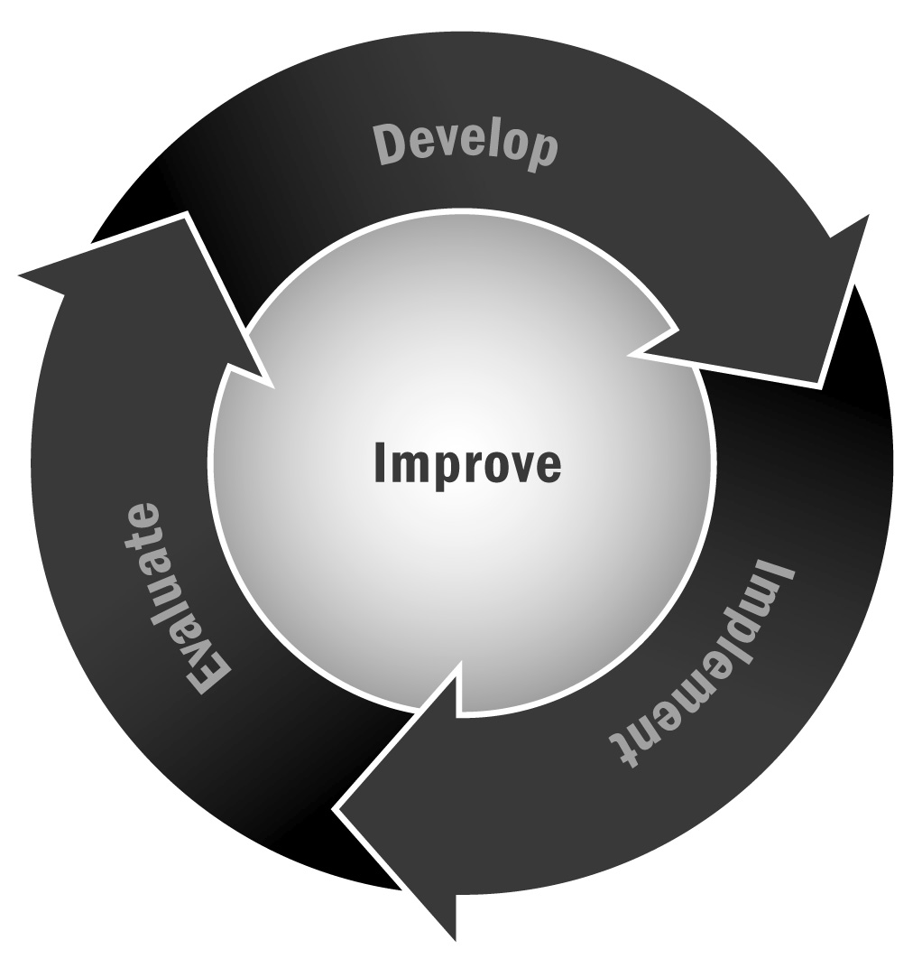
In Chapter 5, you learned about the various steps of an evaluation, from defining the purpose to using the findings to refine your program. Producing a clear and concise evaluation report will help you translate your evaluation’s findings into action. In writing your evaluation report, use the checklist below to ensure that you have covered all necessary areas.
Directions: This tool provides you with a checklist of all the information you may include in an evaluation report. Don’t worry if you don’t include all of the information we have detailed here or in the order we suggest. The good news is that some the information should stay the same from year to year and that you should be collecting a lot of the information for the report throughout the program year. Look at this checklist before you start you evaluation—it may give you some ideas of things you may want to include and gather earlier on.

Evaluation Report Template – Checklist
Title Page | - Name of the program and organization.  - Title of the evaluation.  - Names (and organizations, if external) of the individuals conducting the evaluation.  Comment: Avoid the use of acronyms on the title page. | ❒
Table of Contents | - Provide sufficient detail to guide the reader through the report, including page numbers.  - Include page numbers for boxes, figures, tables, and appendices. | ❒
List of Acronyms | - Include definitions of all acronyms used in the report, in alphabetical order. | ❒
Executive Summary | - Briefly describe the program you are evaluating.  - Explain the evaluation purpose and objectives, making sure to identify the intended users of the evaluation report.  - Describe the main methods and data collection tools used.  - Summarize the key findings, conclusions, and recommendations.  Comment: The executive summary should serve as a stand-alone form of the evaluation report, as intended users of the evaluation report may refer to it independently of the report. The executive summary should not include any information that is not covered in the report. | ❒
Evaluation Purpose and Evaluation Questions | - Define and explain the evaluation purpose. This section should address why the evaluation is being conducted now, the intended use of the evaluation’s findings, and what practical decisions can be informed by the evaluation’s findings, and the section should identify the intended audience of the report.  - Define and explain the evaluation questions detailed in the statement of work, linking these to the evaluation purpose. | ❒
Program Background | - Describe the program that is being evaluated, detailing the various activities of the program.  - Describe the scale of the program, detailing the size of the target population.  - Describe the program’s resources, providing details about the total human resources (staffing) and financial budget supporting activities.  - Identify and describe the key partners that collaborate with your organization in the delivery of the program.  - Explain how the program originated, relating this to the organization’s mission, program vision, and population assets and needs. Support this presentation with research literature and findings from the market analysis, asset mapping, and community needs assessment findings where possible.  - Provide an overview of the program’s vision and goals, including a description of the intended participants, geographic location, and the theory of change supporting the program’s design.  - Describe and explain any changes to the program’s goals or activities that have occurred since its inception.  - Describe any weaknesses in the design of your program and any resource capacity limits on your activities.  Comment: If you have a program logic model, you should include it here, making sure to explain the elements in detail. | ❒
Evaluation Methodology and Limitations | - Provide a description of the methods and data collection tools used in your evaluation.  - Describe the types of data collected (quantitative, qualitative, or mixed).  - Describe who information was collected from (e.g., program participants, staff members, community members, stakeholders) and how these individuals were selected to participate in the evaluation.  - Explain why these data collection tools were chosen and how the data produced were intended to answer the evaluation questions.  - Explain the tradeoffs that led you to decide on particular methods, making sure to describe data availability and quality, sampling strategies, and subject/site selection.  - Explain how stakeholders participated in the evaluation.  - Explain the ethical considerations you took into account while conducting the evaluation. Make sure to explain how you protected the confidentiality of respondents.  - Present evidence supporting the credibility of your findings. For example, explain how stakeholder involvement contributed to the credibility of your evaluation findings.  - Explain any limitations associated with your methodology (e.g., data issues such as selection bias or recall bias, or unobservable differences between comparison groups). Make sure to explain any challenges you faced in collecting data, and whether your methods changed over the course of the evaluation. | ❒
Findings | - Present clear analysis of quantitative/qualitative evidence. Include findings that assess outcomes and impacts of the program.  - Describe your findings. For example, you could present frequencies, percentages, and averages or visual depictions of quantitative data; for qualitative data you could summarize patterns or clusters of respondent answers.  - Avoid interpreting your findings in this section: “interpretations” often refer to why the objectives were not achieved, and are presented in the next section of the report.  Comment: Consider structuring this section around the evaluation questions so that the user of the report can easily draw connections between what was asked and what was found by the evaluation. | ❒
Conclusions and Recommendations | - Conclusions and recommendations should synthesize and interpret the findings of the evaluation and make judgments supported by specific findings.  - Provide recommendations that are action-oriented, practical, and specific. Define who is responsible for the action.  - Evidence supporting conclusions and recommendations should be presented visually where possible to aid the readers’ understanding of judgments made.  Comment: Consider structuring this section around the evaluation questions so that the user of the report can easily draw connections between what was asked and what was found by the evaluation. | ❒
Appendices | - Statement of work  - Methodology-related documentation, including the evaluation matrix and copies of the data collection tools used (e.g., questionnaires, surveys, and checklists)  - Lists of individuals interviewed, including position title  - List of sites visited for data collection purposes  - Short biographies of the evaluators  Comment: Consider structuring this section around the evaluation questions so that the user of the report can easily draw connections between what was asked and what was found by the evaluation. If this is not possible for this section, put the recommendations in priority order. | ❒
References | - A comprehensive list of sources, including documents reviewed, external data sources, and key discussants | ❒

