92

Post-Evaluation Planning Tool
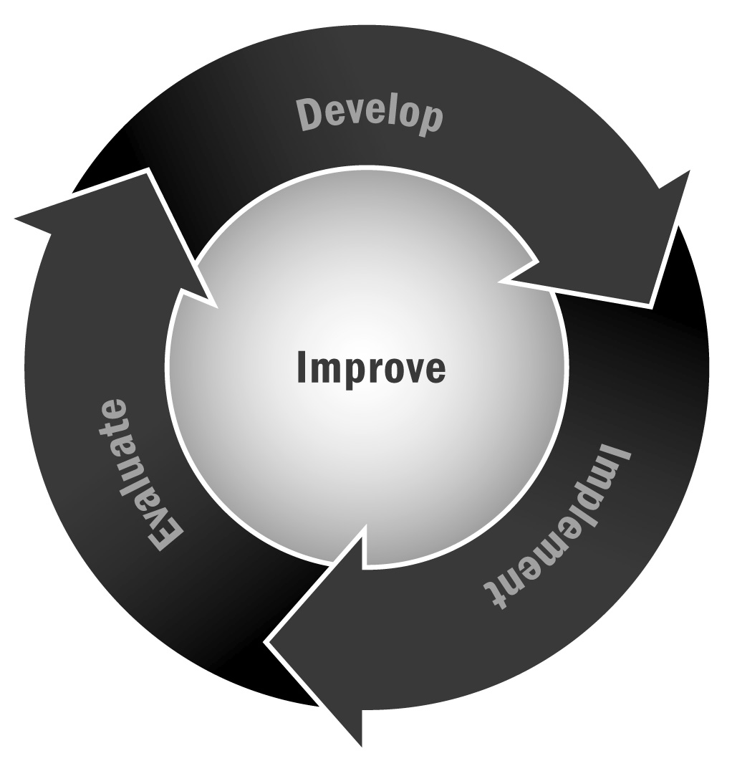
In Chapter 6, you learned that it is important to take the time to use your evaluation results for future planning. Rather than just noting the results, you and your team should sit down and discuss what actions you are going to take to improve your program based on what your evaluation is telling you.
Directions: This tool outlines some of the key steps you may want to take in using your evaluation results to plan and make changes to your program. We suggest you undertake the actions in this tool with a team—this team may include staff members, advisory board members, family members, partners, and youth.

Step 1 – Talk With Your Evaluator (If You Have One)
If you had an evaluator helping to assess your program, don’t just have them turn in a report and disappear. Now you need them more than ever. Ask your evaluator to come to a meeting with your planning team or meet with you one on one to go over the results and share key strengths and key areas for growth. Sometimes evaluation results can be confusing and hard to understand. Things like effect sizes and statistical significance don’t mean much to those without a research background, so it is important for your evaluator (or someone with expertise if your evaluator can’t or won’t do this) to translate those findings into lay terms.

Step 2 – Review Evaluation Findings
Again, with your team and ideally your evaluator, review the evaluation findings. Make sure everyone involved in the planning session understands what the findings mean. Pull out key points and highlight them on chart paper or in a PowerPoint slide. Focus on what is working as well as what might need to be improved. Now is the time to look at all the findings. You don’t need to prioritize yet—just make sure that everyone understands the findings and is able to focus on the key points.

Step 3 – Prioritize Findings
Evaluations can be overwhelming, especially if they are comprehensive and consider many different factors. If you and your team try to come up with action steps to address every finding, you may end up feeling frustrated and discouraged. Instead, use this time with your planning team to prioritize two or three areas for growth in the short term and two or three for the long term. Start by filling in the chart below.

Target Improvement Areas
Area for Growth | Long Term or Short Term? | Is It Fixable? | Level of Importance
In this column you should list all the areas for growth identified in your evaluation. Try to create a succinct description or target issue. | Note whether this is a long-term or a short-term fix. For example, if your evaluation finds that youth feel unsafe in the program, this may be an urgent, short-term goal you want to address now. If the evaluation finds that families want a new summer program to go with the school year program you currently offer, this may be a longer term issue. | This is a yes/no column. Indicate whether the target area is something you can actually fix or not. | Here you should indicate how important this issue is to you and your team.

Step 4 – Create an Action Plan
Take the time now to discuss the chart with your planning team. You can immediately eliminate the areas or issues you can’t fix. It is tempting to get caught up discussing things you really have no control over. Don’t! If it isn’t something you can change, cross it off and move on. Likewise, you can look at the column related to level of importance and cross off the areas that simply aren’t a priority for your program. Perhaps an evaluation finding is related to something tangential to your mission or not of particular importance to your program. Once you have eliminated low-priority and unfixable issues, you should be left with a more reasonable list of target areas. Now look at the short and long term column. You should select only two or three short-term and two or three long-term target areas to keep your action plan realistic. Discuss priorities with your team and enter them into the table below. Discuss your key action steps, deadlines, and assigned staff members. Be sure to revisit this planning grid at least quarterly at staff meetings or other key gatherings to ensure that you are making progress on your goals.

Action Plan
Area for Growth | Action Steps | Timeline | Lead Staff
List your four to six short- and long-term priorities in this column. | Develop specific action steps to address each area. Be concrete. | Indicate short or long term and when you hope to see action steps accomplished. | Identify a staff member to take the lead for each area.

