88

Tips for Running Good Focus Groups
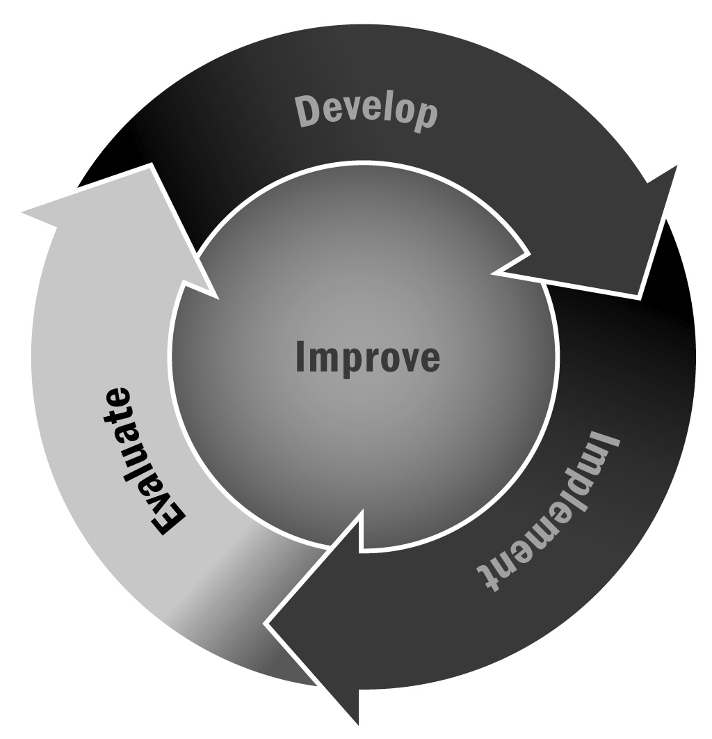
In Chapter 5, you learned that no matter how well you plan your activities, your evaluation questions, and your evaluation plan, it will all be for naught if you don’t have a useful way to collect the data you will need to answer your evaluation questions. One way to collect data is through focus groups.
Directions: Use the following tips when running focus groups. Focus groups might be with youth, families, community members, or potential providers. You will need to identify the groups of people you want to talk to, develop a focus group protocol that includes the questions you want to ask, schedule the groups at a time that is convenient for your participants, and identify people to conduct the groups. Generally, focus groups should include five to eight people. Any more can get unwieldy, but fewer than five requires people to talk too much.
- It is important to choose or set up a physical space for the focus group that is going to feel welcoming and comfortable to the participants. It should be neutral, private, free from distractions, and easily accessible.
- Arrange participants in a circle.
- Tell participants where the bathrooms are.
- Provide refreshments if possible and place them away from the circle to avoid distractions.
- Have at least two people facilitating the focus group: a moderator and a note taker.
- Keep an open mind about the participants and what they might say.
- Remain neutral throughout the focus group and be careful about using common phrases such as “that’s good” or “excellent” and nonverbal cues like nodding your head.
- Make sure the questions flow (i.e., are logically sequenced), practice them out loud, know why you are asking each question, and know how much time you plan to spend on each question.
- Take notes, record the focus group, and transcribe the recordings. Be sure to check that the tape recorder is working before the focus group starts, and have a back-up recorder with you.
- Be ready for unexpected problems, such as bad weather, fewer participants than expected, poor meeting space, inadequate preparation by the field coordinator, participants bringing other adults, other uninvited people showing up, or a group that doesn’t want to talk.
- Anticipate running low on time—think about what you would do to modify the agenda.
- Debrief after the focus group to finalize notes and discuss any overall impressions and key ideas.

