87

Tips for Developing and Administering Surveys
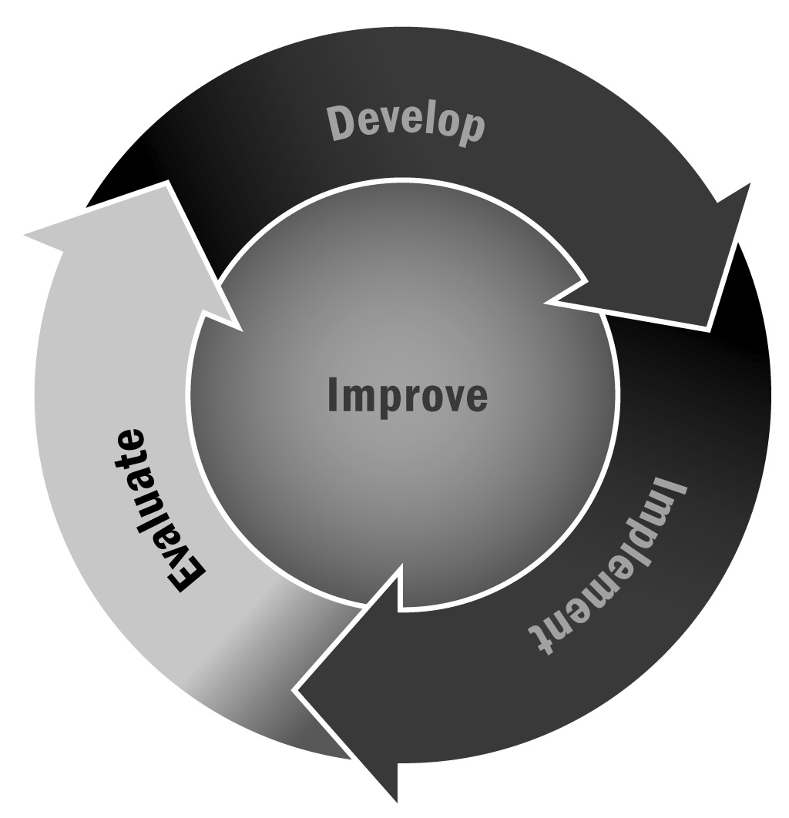
In Chapter 5, you learned that data collection is a key part of measuring your program’s success. If you decide to develop your own survey, ensuring that it is clear and precise will contribute to more reliable data.
Directions: Use the following tips when creating a survey. You can also use this guide as a checklist as you are developing a survey.

Survey Goals
- Consider what you hope to find out from a survey and from whom you would like to gather data. Is this survey asking for opinions, such as family or youth satisfaction with the program? Or is it more of an outcome-focused data collection, such as determining youth engagement in your program? This may impact how you design and administer your survey and what types of questions you decide to ask.
- If you are collecting data on youth and asking them to fill out a survey to do so, you may need to get parental consent. Make sure you are familiar with the legal and institutional requirements for administering data collection surveys to youth beforehand.
- Think about the audience you are targeting and consider how receptive and sensitive it might be to the questions you want to ask. Make sure to incorporate these considerations when designing the survey questions and administering the survey.
Questions: General Tips
- Prioritize your selection of survey questions. Only ask questions that you are really interested in learning about and that will be useful for your program. It can be tempting to ask all the questions you may want to know about when conducting a survey, but this makes it more burdensome for respondents and can impact the quality of your data.
- Write short questions that respondents can read quickly and easily when taking the survey. If respondents have to read a question more than once, they may be less willing to finish taking the survey or more likely to misunderstand the question, which will impact your results.
- Ensure that each question has only one central idea. An example of asking a single question with multiple ideas would be “Were activities appropriately difficult and well-paced for your child?” These ideas should be separated into distinct questions so that the respondent can answer each individually, as they may have different responses to the two ideas. For example, you could ask, “How would you rate the difficulty of the activity for your child?” and “How would you rate the pacing of the activity for your child?”
- Consider the audience you are trying to reach and make sure the survey is understandable to this group (e.g., youth or adults, people inside or outside the program, special language or reading needs, and so on). Try to avoid jargon that may be difficult for your audience to understand.
- Use precise language in your questions (e.g., at least once a week, once a day) and avoid vague words (e.g., generally, usually, typically, about what often, and rarely). Using more specific words will improve the quality of your data by communicating clearly with respondents you would like to know.
- Focus your questions on asking for suggestions for improvement, rather than focusing on negative experiences. For example, instead of asking, “What did you dislike about the activities?” instead ask, “How can the activities be improved?” This avoids focusing on the negative aspects while also providing constructive information about what respondents would like to see in the program.
- Avoid leading questions that appear to advocate a particular answer. Such questions will impact the quality and accuracy of your data.
- Provide instructions on how to record answers and how many options to select. For example, state clearly how many options the respondent should select for multiple-choice questions and how to select their answer (e.g., circle the statement, check a box).
- Create a survey that is clear, easy to follow, and aesthetically pleasing. This will encourage respondents to complete the survey by making it less burdensome (and less burdensome looking), and will allow respondents to follow the flow of the survey.
- Pilot your survey. Before sending it out to the entire audience you would like to survey, ask a small group to take the survey beforehand so that you can incorporate its feedback. It may help to include individuals who would not ordinarily take the survey in addition to individuals from the audience you are trying to reach. Ask them questions such as whether the questions are easy to understand, how long the survey took, and whether they have any other concerns about the survey.
- Make sure to place more specific questions first in the sequencing of the survey. For example, you could ask, “How would you rate this afterschool and expanded learning program?” followed by, “How would you rate the afterschool and expanded learning programming available in your community?” This prompts the respondent to consider your program separately from others offered in their community.

Questions: Multiple-Choice Questions
- Allow respondents to write their own answers or select an “Other” option. It is possible that multiple-choice questions will not include all the possible answers, and providing extra options could improve the quality of your data and give you more information about your respondents.
- When appropriate, consider asking respondents to rank their responses to questions that allow multiple answers. For example, consider asking youth to rank the top five types of programs they would be interested in attending, with 5 being the most interested and 1 the least. However, make sure that ranking is appropriate for the question. Some questions may lend themselves better to simply checking off options, and asking for ranked options could be more burdensome for respondents.
- Make sure response option scales go in the same direction. For example, do not make one option start with “Strongly Disagree” and lead to “Strongly Agree” and the next question go the opposite direction, from “Strongly Agree” to “Strongly Disagree.” This will confuse respondents and may result in unreliable data.
- Provide categories for all responses on a scale. For example, instead of providing options 1 through 4, where only 1 and 4 are labeled “Strongly Disagree” and “Strongly Agree,” respectively, ensure that 2 and 3 have clear sentiments associated with them as well (e.g., 2 = “Disagree” and 3 = “Agree”).

- If possible, avoid neutral response options and only provide an even number of response options. If you offer respondents a choice of 5 responses on a scale, where the middle response is “Neutral,” they may choose the neutral option to avoid expressing a more dramatic opinion. This can lead to unnecessary ambivalence in your data.
- Although you do not want to provide a neutral option, be sure to include a “Not Applicable” response option that allows respondents to indicate that they do not have enough information to complete a question. If this is not an option, respondents may either choose an option that does not really reflect their views or may skip the question.
Administering Your Survey
- The way you deliver the survey has important consequences for the type of responses you might expect to receive, the type of respondent you will reach, and the format of your survey questions. Therefore, it is important to think about whether the survey will be delivered by mail, telephone, in person, or online, and how these different methods will affect the survey design. It is likely that a paper survey will be the most convenient method for respondents, but an electronic survey has advantages as well (such as allowing for skip logic and requiring less data entry) if it seems like a viable format for your respondents. Popular online survey sites include SurveyMonkey (http://www.surveymonkey.com), Survata (http://www.survata.com), and Zoomerang (http://www.zoomerang.com), but there are many options to choose from.
- Try to limit how long the survey will take respondents. Although you may have a lot of questions you want to ask, respondents will be less likely to complete a survey that takes a long time to fill out. It is also helpful here to consider your audience, as having shorter surveys may be more important for certain groups (such as youth).
- Depending on how you intend to deliver the survey, you might want to include a compelling introduction explaining why the survey is being conducted, why the respondent’s view matters, and that responses will be confidential. This will help create buy-in with respondents.
- Provide respondents with a person they can contact if they have any questions or concerns about the survey.
- Consider how long the survey will take and include this estimate in the introduction to the survey. This way, respondents can plan accordingly and you will have fewer respondents who sit down to take the survey and then stop without completing the survey because it took longer than they anticipated.
- Surveys can require an intense amount of follow-up to get a useful number of responses. When considering a survey, think about how you will follow up, who will conduct the follow-up, and when you will want to do it. Respondents may need reminders, but it is also important to be respectful of their time and other obligations.
- Depending on the nature of your survey, you can consider providing incentives or the possibility of incentives (e.g., a drawing of respondents for a gift card or other item). This will increase the cost and logistical burden of administering a survey, so consider whether the incentives are truly necessary or helpful before deciding to offer them.
Managing Your Survey Data
- Have one person in your organization whose role it is to enter the data if you are giving a paper survey. This will ensure that the data are entered consistently.
- In addition to having a single person responsible for entering the data, it is also helpful for this person to document or log how the data are entered and what he or she does when there are inconsistencies in the data. This will ensure that others can use or enter the data consistently as well if this staff member leaves or changes roles.

