86

External Evaluator Questions and Worksheet
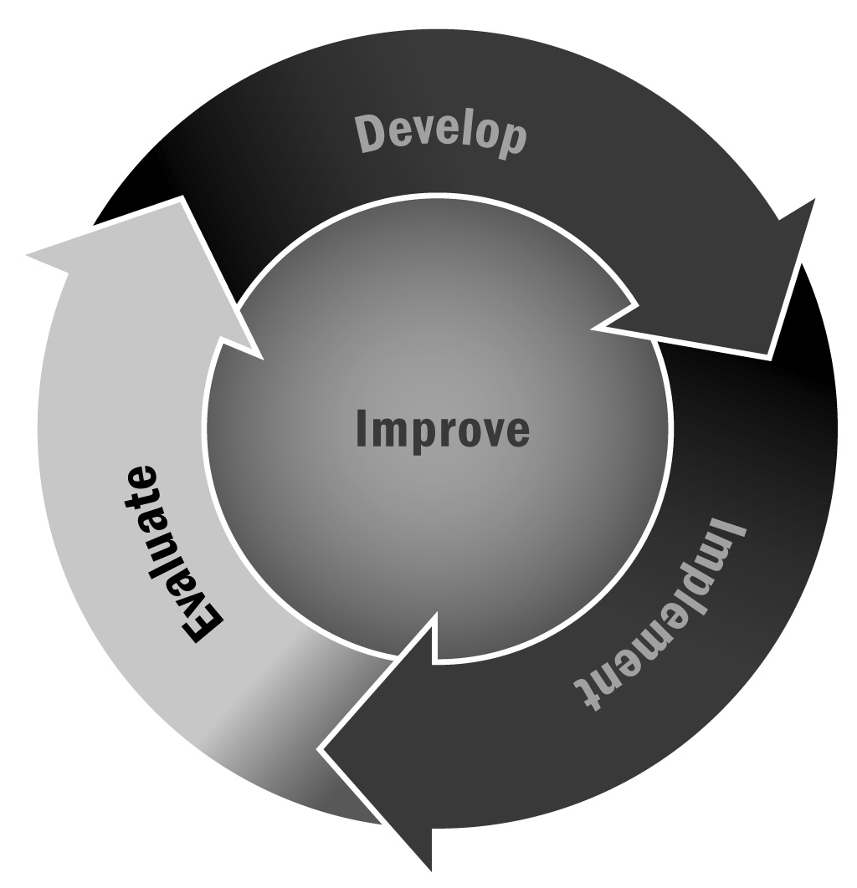
In Chapter 5, you learned that finding an external evaluator that is a good fit for you and your program is critical for conducting an evaluation that is useful for you. Interviewing potential evaluators and asking key questions will help you choose an evaluator that is right for you.
Directions: When considering an external evaluator, use the following general guidelines and ask the following questions, filling in relevant program-specific elements where necessary. Then use the worksheet on the pages that follow when meeting with potential external evaluators.

General Guidelines
- Look for experience in evaluations generally and in your program type specifically.
- Look for a research base that informs the evaluator’s strategies.
- Look for attitudes regarding evaluation that suggest compatibility with your program, evaluation goals, and organizational dynamics.
General Questions
- What is your general experience in evaluation?
- What is your general experience with afterschool and expanded learning programs?
- What is your knowledge base about programs like ours? About youth or stakeholders like ours?
- How do you ensure that the evaluation plan is nonintrusive to partners and youth?
- We want to know X about our program. Have you answered this type of question before for other programs?
- What evaluation approaches do you think are relevant to our situation? What evaluation approaches do you recommend in these kinds of circumstances?
- What do you consider to be characteristics of a strong evaluation? A weak evaluation?
Specific Questions on Evaluator Functioning
Generally you contract with the evaluator, who provides a cost estimate for services that the two of you have discussed. As to how these services get done, certain aspects may be less relevant. For example, does it really matter if the evaluator sends data out to be entered or does it himself or herself? You do have every right, however, to know how the evaluations are staffed to ensure that the individual components are being conducted by qualified personnel. To influence your decision, you might want to ask the following questions:
- How many staff members work for you?
- How do you structure the work?

These questions can lead to other questions regarding who does what and how hands-on the evaluator will be. Will the evaluator have more of a management role in the evaluation and delegate work to lower level staff? Or will the evaluator do most of the tasks himself or herself? If you are working with a larger organization, you can expect the former, which can end up being more cost-effective for you. The evaluator may delegate the work, but he or she is your contractor and the quality-assurance funnel that everything goes through before it gets to you. If you’re working with an independent consultant, chances are that he or she will be much more hands-on in the work, although it’s likely that tasks such as data entry and routine analysis will be delegated to administrative staff members or other service providers.
- Do you sub-contract for any services? Can résumés of vendors be provided for our information?
- How frequently do you submit reports?
Regarding reporting, you are ultimately the one who determines the reporting schedule. You’ll discuss with the evaluator a schedule of reporting, both internal and external, that meets the evaluation requirements and keeps you informed.
- What information will your evaluation provide, and how will that information be provided?
- Who will:
- Develop the data collection instruments?
- Collect the data?
- Process the data?
- Analyze and evaluate the data?
Specific Questions on Funding
First you will need to determine your budget. This will greatly shape the role the evaluator plays. The most involved role an evaluator can play is designing the actual evaluation and planning the management of it (e.g., staffing and timelines). The second largest role an evaluator can fill is actually managing the evaluation in terms of tasks, timelines, and budget, which takes this role off your shoulders. If you don’t have a lot of extra money, use local resources—such as program or district staff members—to the degree that they have availability and expertise. If there is extra money, these additional tasks should be taken on by the evaluator. Be sure to probe how the evaluator works with his or her clients (you).
- What is your rate?
- What will be your role in the evaluation?
- What additional tasks will be your responsibility?
Specific Questions on References
- Could you provide references from groups or agencies similar to ours that have used your services?
- Do you have samples of reports from previous evaluation projects?
- How well have you met deadlines in previous work?
- What are your procedures regarding confidentiality?

External Evaluator Review Worksheet
Organization:
Name:
Date:

Question | Notes
General Questions
What is your general experience in evaluation?
What is your general experience with afterschool and expanded learning programs?
What is your knowledge base about programs like ours? About youth or stakeholders like ours?
How do you ensure that the evaluation plan is nonintrusive to partners and youth?
We want to know X about our program. Have you answered this type of question before for other programs?
What evaluation approaches do you think are relevant to our situation? What evaluation approaches do you recommend in these kinds of circumstances?
What do you consider to be characteristics of a strong evaluation? A weak evaluation?
Evaluator Functioning
How many staff members work for you?
How do you structure the work?
Do you subcontract for any services? Can résumés of vendors be provided for our information?
How frequently do you submit reports?
What information will your evaluation provide, and how will that information be provided?
Who will develop the data collection instruments?
Who will collect the data?
Who will process the data?
Who will analyze and evaluate the data?
Funding and Cost
What is your rate?
What will be your role in the evaluation?
What additional tasks will be your responsibility?
References
Could you provide references from groups or agencies similar to ours that have used your services?
Do you have samples of reports from previous evaluation projects?
How well have you met deadlines in previous work?
What are your procedures regarding confidentiality?

