85

Program Observation Tools
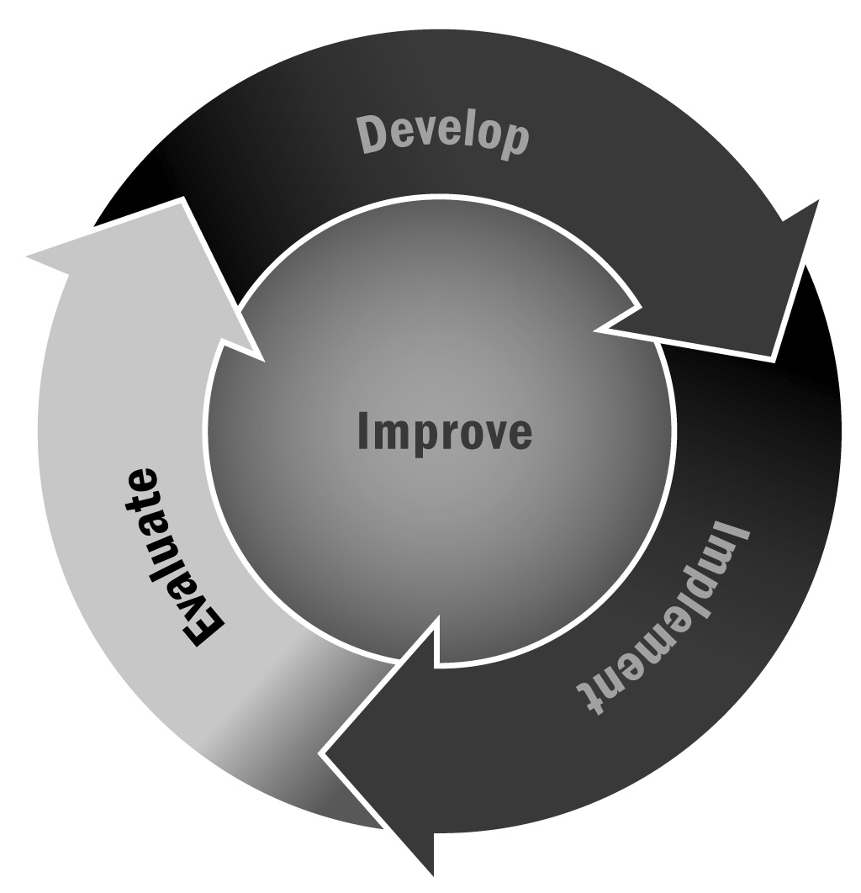
In Chapter 6, you learned that it is a good idea to monitor the quality of your program using some kind of observation tool. Using an observation tool can be a good way to capture information about your activities that you can then share with your staff to celebrate success and encourage improvement.
Directions: Program observation is typically part of a larger quality improvement system. Although there are many observational assessments available for programs to use, the tools included in this document are some of the most common in the field, and all meet a set of criteria: They are research-based, are appropriate for a variety of program settings, and focus on the interactions among people in the program. Many of the tools are available for free, but are most useful when implemented as part of a larger quality improvement process that includes professional development, coaching, and a consistent focus on using data to drive improvement. The tools listed below were included in a review of commonly used program quality assessments in afterschool and expanded learning settings (Yohalem & Wilson-Alhstrom, 2009). In addition to reviewing the following information, we recommend visiting the developers’ websites to find new and updated versions of the tools.

Common Tools
- Assessing Afterschool Program Practices Tool (APT)
National Institute on Out-of-School Time and Massachusetts Department of Elementary & Secondary Education
- Out-of-School Time Observation Tool (OST)
Policy Studies Associates, Inc.
- Program Quality Observation Scale (PQO)
Deborah Lowe Vandell and Kim Pierce
- Program Quality Self-Assessment Tool (QSA)
New York State Afterschool Network
- Promising Practices Rating Scale (PPRS)
Wisconsin Center for Education Research and Policy Studies Associates, Inc.
- Quality Assurance System® (QAS)
Foundations, Inc.
- School-Age Care Environment Rating Scale (SACERS)
Frank Porter Graham Child Development Institute and Concordia University, Montreal
- Youth Program Quality Assessment (YPQA)
David P. Weikart Center for Youth Program Quality

Target Age and Purpose
 | Program Target Age | Primary Purpose |  |  | Target Users |  |  | Data Collection Methods
 | Grades Served | Improvement | Monitoring/ Accreditation | Research/ Evaluation | Program Staff | External Observers | Observation |  | Interview | Questionnaire | Document Review
Assessing Afterschool Program Practices Tool (APT) | Grades  K–8
Out-of-School Time Observation Tool (OST) | Grades  K–12
Program Quality Observation Scale (PQO) | Grades  1–5
Program Quality Self-Assessment Tool (QSA) | Grades  K–12
Promising Practices Rating Scale (PPRS) | Grades  K–8
Quality Assurance System® (QAS) | Grades  K–12
School-Age Care Environment Rating Scale (SACERS) | Grades  K–6
Youth Program Quality Assessment (YPQA) | Grades  4–12
Adapted with permission from: Yohalem, N., & Wilson-Alhstrom, A. (2009). Measuring youth program quality: A guide to assessment tools, second edition. Washington, DC: The Forum for Youth Investment.

