84

Indicators for Program Goals
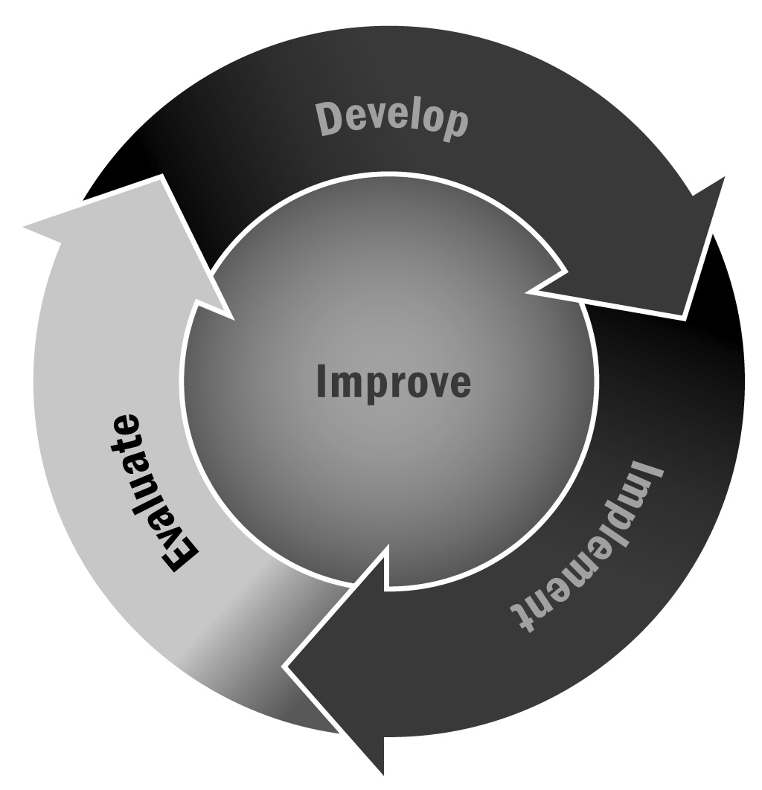
In Chapter 5, you learned that identifying indicators is a critical step in assessing whether your program is meeting its goals. Choosing indicators that relate directly to your program’s goals will ensure that you can measure your program’s progress and can identify activities to help achieve these goals.
Directions: Use this tool to develop indicators for your goals. After you have agreed on goals, identify a set of indicators for each goal and answer the questions about each one. Then assign activities that lead to the eventual achievement of the goals. This order should be followed carefully. An example of a completed form is on the next page and a template that you can use is on the page that follows.

Goal and Indicator Alignment Table – Example
Goals* | Possible Indicators | Questions to Ask About Each Indicator |  |  |  | Activities
 |  | Is This Indicator Relevant? | Will This Indicator Provide Sufficient Information? | What Data Sources Are Available for This Indicator? | Is This Indicator Quantifiable?
Improve youth achievement in mathematics | Mathematics grades improve | Yes | Yes | - Report cards  - Test scores | Yes | 1. Homework help session  2. Family math  3. Chess club  4. Computer-based math activities  5. Peer-tutoring group
 | Teachers report that youth now have homework in on time and correct | Yes | Yes | - Teacher survey | Yes
 | Youth report that they better understand math assignments | Yes | Yes | - Youth survey | Yes
 | Youth enjoy math more than before | Yes | Yes | - Youth report  - Teacher observation | Maybe
 | Fewer youth are in remedial sections of math | Yes | Yes | - Office records | Yes
**Use your Tool 37: Goal Setting Worksheet and insert those goals here.

Goal and Indicator Alignment Table – Template
Goals* | Possible Indicators | Questions to Ask About Each Indicator |  |  |  | Activities
 |  | Is This Indicator Relevant? | Will This Indicator Provide Sufficient Information? | What Data Sources Are Available for This Indicator? | Is This Indicator Quantifiable?
*Insert your goals from Tool 37: Goal Setting Worksheet here.

