83

Determining Your Evaluation Purpose Worksheet
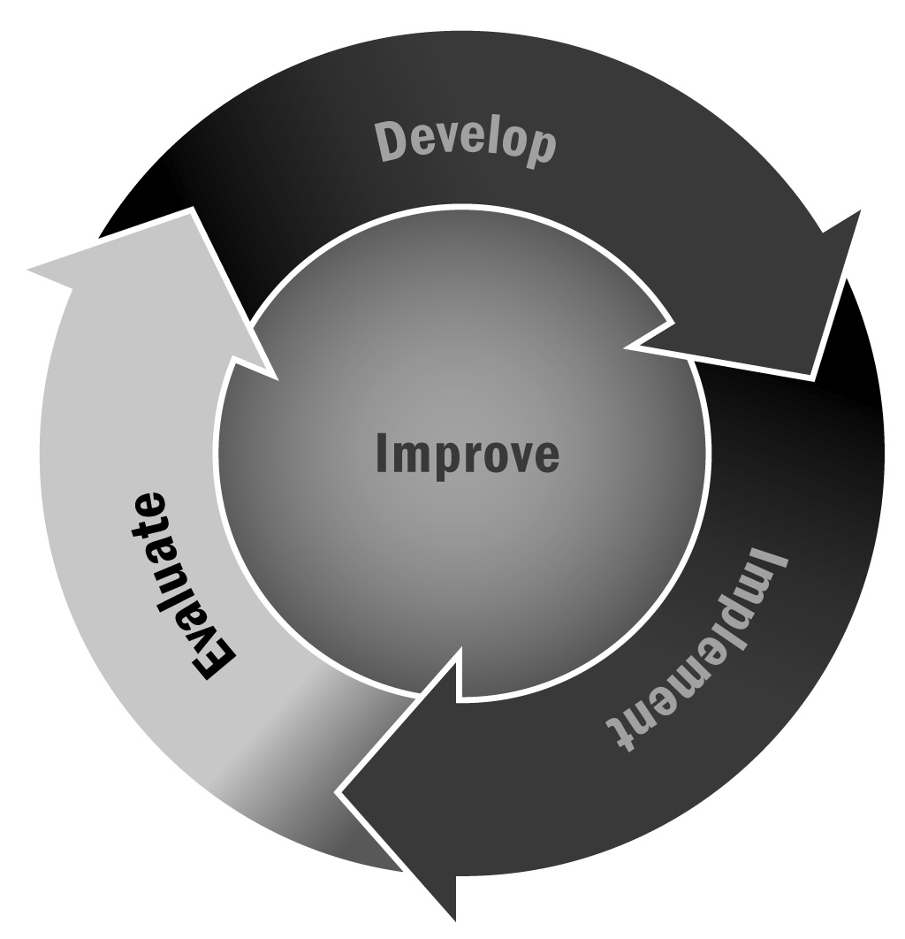
In Chapter 5, you learned that it is crucial to determine the purpose and scope of your evaluation very early on in the process. You need to decide what is important and relevant to you and your stakeholders, as well as understand what is feasible. Framing a clear and concise evaluation purpose will help you decide who will perform the evaluation, help you develop evaluation questions, and help you set up a data collection system.
Directions: Gather together a working group of staff members who are familiar with how the program is currently managed and also how it currently conducts evaluation activities. Use the worksheet on the following pages to guide discussion. Jot notes down in the space provided and use the answers to move toward a clear and concise evaluation purpose.

Connecting Developmental Stage of Program to Appropriate Evaluation Activities
This table provides some recommendations for what type of evaluation activities and goals you might have at each stage of your program’s development. Identify where your program is in its developmental lifecycle and review the suggested evaluation purpose and activities for ideas. This is a starting point to help you as you discuss the questions below.
Program Stage | Characteristics of Program | Suggested Evaluation Purpose
New Program | Your program is at “square one,” because it either has just been started or has been substantially changed. | The program should begin developing data collection procedures on a small set of targeted measures. The evaluation purpose should focus on program activities, outputs, short-term outcomes, and participant satisfaction in order to assess program implementation.  Methods might include end-of-program surveys, monitoring enrollment and participation rates, program quality observations, focus groups, and interviews with key people in the program.
Developing Program | You have implemented your program successfully for one or two years. Though some or most of your program elements are being implemented consistently, you are still experiencing change. | The evaluation purpose should focus on changes in outcomes that might be associated with the program as well as continue to monitor implementation.  Methods could include pre- and post- surveys, comparing outcome indicators (such as attendance, behavior, school connectedness) before and after participation to identify trends and begin to determine whether (but not prove) positive changes are associated with the program.
Mature Program | You have implemented your program successfully and consistently for more than one or two years. Participants’ activities, experiences, and responses are consistent across sessions. The afterschool and expanded learning program has formal procedures, protocols, and lesson plans in place, and these are followed consistently by staff. Mature programs might also be implemented across multiple sites. | The evaluation purpose should focus on the effectiveness or impact of the program, investigating whether the program caused intended outcomes.  Methods include statistical controls, comparison groups, or experimental/quasi-experimental procedures.

Evaluation Purpose Worksheet
Evaluation Goal
1 | What is your goal for the evaluation?  For example, is your goal to gather data that will help you to improve the program, or to report on the effectiveness of your program to stakeholders? Or is your goal a combination of both?

Funder and Stakeholder Interests
1 | What do your funders require you to report?  What type of evaluation are you obligated to conduct?  Funders will have priorities regarding which program elements they want to be evaluated, and what kind of information is useful and credible to them.
2 | Which stakeholders have an interest in your evaluation activities or results?  Are there any outcomes that multiple stakeholders have a keen interest in?  The evaluation purpose should focus on the outcomes with the most stakeholder interest to ensure the findings are useful and relevant to their needs.

Evaluation Capacity
1 | What financial resources are available for the evaluation?  If the budget available for the evaluation is small, this limits the scope and purpose of the evaluation. External evaluation generally requires more financial resources than internal evaluation.
2 | Which staff members can contribute to the evaluation?  What formal or informal evaluation expertise do those staff members have (e.g., survey design, research methods, statistical/data analysis)?  If staff expertise is limited, you may want to limit the scope of your evaluation or consider contracting with an outside evaluator.
3 | How much time can these staff members provide?  If staff members cannot dedicate substantial time and energy to the evaluation, you may want to limit the scope of your evaluation or consider contracting with an outside evaluator.
4 | What information do you already have or collect?  What data collection processes do you currently use (e.g., attendance sheets, satisfaction surveys, web-based tracking system)?  What data elements would you like to collect as part of an evaluation?  For instance, if you don’t currently collect data on participant satisfaction it will be difficult to focus your evaluation purpose on the participants’ responses to the program. Alternatively, you could develop a data collection tool and start collecting these data.
5 | Which elements of your program are most critical (revisit your logic model, Tool 40, and your theory of change, Tool 39, to identify the program elements that are most likely to contribute to improve youth outcomes). Do you have data regarding these elements?  For example, if attendance is the most important output of your logic model, then having data on attendance will help you to determine whether your goals are being achieved.
Now What? After discussing the questions with your evaluation planning team, you should have a better sense of what your evaluation purpose and priorities are. You may now be able to make decisions about the following questions:
- Should we use an external evaluator?
- Will we conduct a formative or summative evaluation?
- Are we using a comparison group?
- What is our primary evaluation purpose?
As you answer these questions and finalize your plans, craft a purpose statement that you can share with potential evaluators so you can be sure they understand your goals and can help you develop an evaluation plan that makes sense for your program.

