81

Homework Sharing Tool
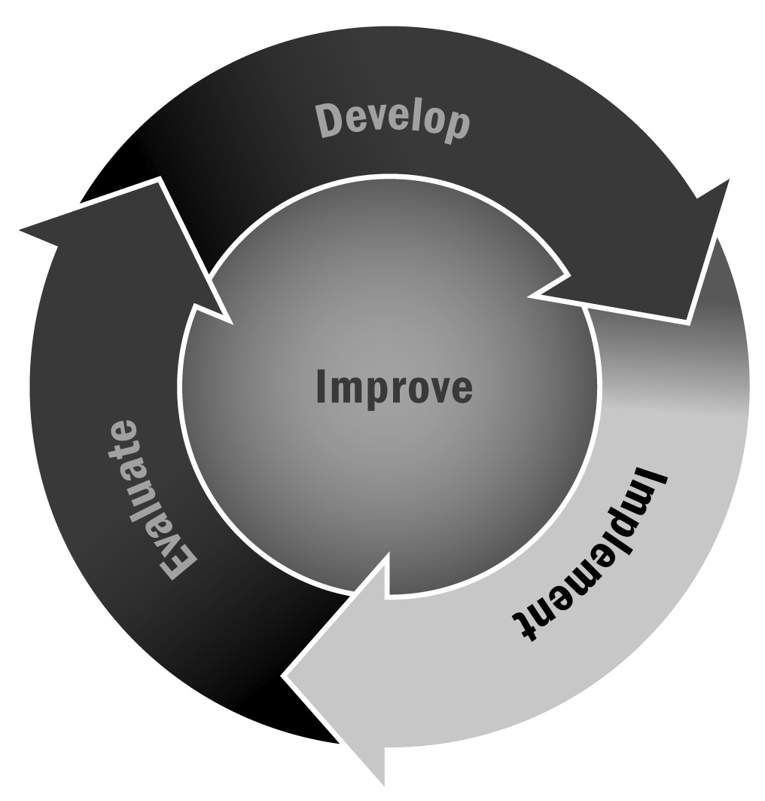
In Chapter 4, you learned that homework help and tutoring activities are often an integral part of afterschool and expanded learning programs. Providing a dedicated time and space for youth to receive help on their schoolwork can help youth improve their academic performance. Creating opportunities for school day teachers and afterschool and expanded learning program staff members to share information and keep track of youth’s work can facilitate this goal.
Directions: This form can be used by the school day teacher and program staff members to share information about an individual’s homework assignments and study habits. For each homework assignment, the teacher fills out the information in the left column and gives the form to the program staff member. After assisting youth, the program staff member fills out the information in the right column and returns the form to the teacher. Youth complete the section at the bottom. For younger youth, the staff member can help them with what to include in their section.
Note: This form is an example of the kind of information teachers and program staff members can share. It may not be realistic to expect a teacher to complete this form every day for every youth in the afterschool and expanded learning program. Instead, use it periodically to establish a relationship between teachers and staff members or adapt it to a form that teachers are willing to complete daily.

Homework Information Form
Youth Name: |  | Date:
Teacher Name: |  | Afterschool and Expanded Learning Staff Member Name:
Completed by Teacher |  | Completed by Afterschool and Expanded Learning Staff Member
The homework for today is: |  | This young person:  - Completed the homework easily and independently  - Had difficulty understanding what was asked in the homework  - Had difficulty completing the homework  - Had difficulty focusing on the assignment  Comments:
Please pay special attention to: |  | This young person required:  - No help with the assignment  - A little help  - Moderate help  - A great deal of help  Comments:
This homework should take _______ minutes  to complete. |  | The homework took _______ minutes  to complete.
Completed by Youth
This homework was:  - Easy  - Just right  - Hard |  | I have questions about:
Staff Member Signature: |  |  | Youth Initials:

