75

Academic Enrichment Activity Planning Tool
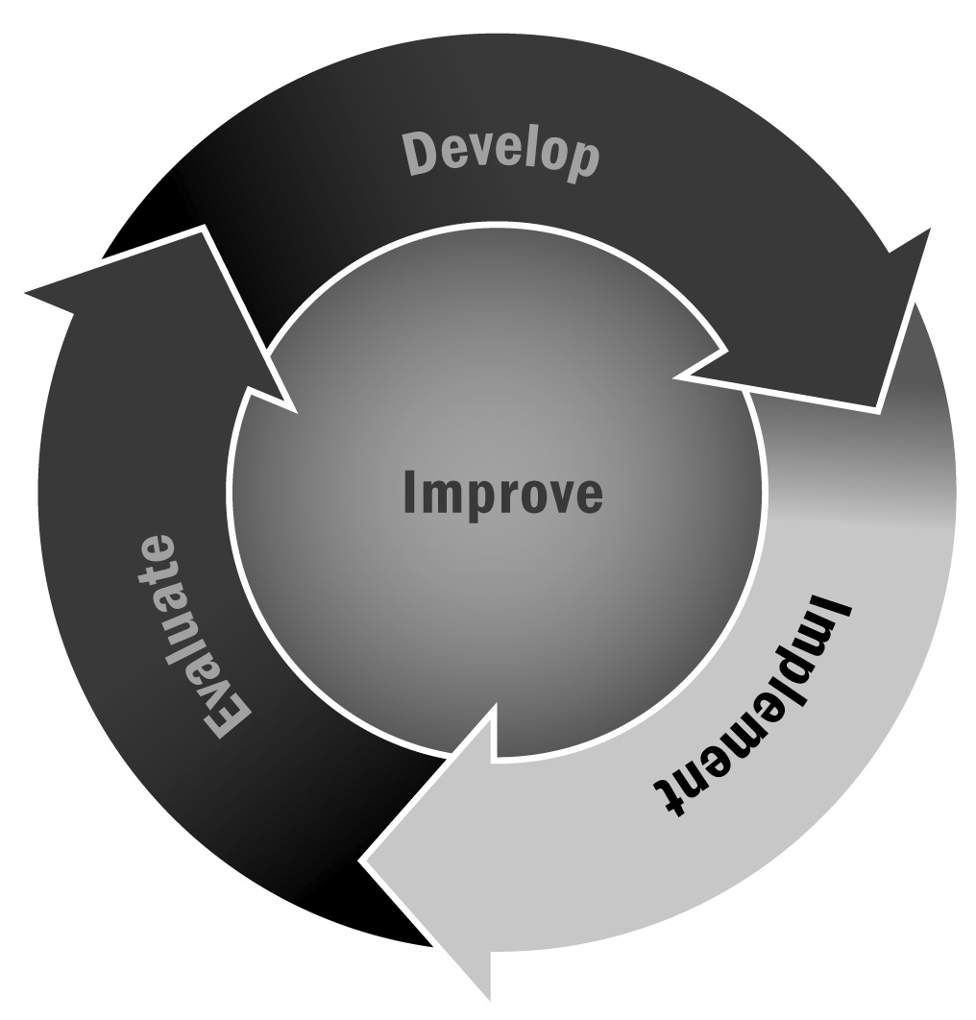
In Chapter 4, you learned that academic enrichment activities and projects (sometimes referred to as embedded learning) present academic concepts in ways that differ greatly from traditional school day instruction.
Directions: Use this tool to plan your academic enrichment activities or projects to make sure they meet academic learning goals and also to present information in a way that draws on recommended youth development practices. Staff members can reference Tool 53: Aligning With Learning Standards to help strengthen the connections between the activity or project and explicit learning outcomes.

Activity Name
Give the activity or project a name.

Description of the Activity
Provide a general overview of the activity.

Desired Outcomes for This Activity
List the desired learning outcomes from the activity. Be sure to address which academic standards will be strengthened by the activity or project. Also list the various skills and competencies that will be explicitly targeted. Plan your academic enrichment activities based on participants’ academic needs, social needs, and interests. For example, two possible goals for a business development activity might be:
- Example: Improve arithmetic skills (budgeting, making change)
- Example: Encourage youth to use creativity in advertising (research marketing strategies)

Is This an Enrichment Activity?
Check the appropriate boxes below for the activity you have chosen:
The activity integrates academic content.
The activity links to subjects youth are currently studying.
The activity teaches academic concepts through methods that differ from typical school day instruction.
The academic learning happens as an intrinsic part of a fun, engaging activity.
The activity encourages youth to apply the learning they are doing to their own experience or to witness how academic concepts are used in real-life situations.
The activity encourages youth to take on leadership roles.
The activity promotes positive relationships among youth (across different ages) and between youth and caring adults.
The more boxes you have checked, the more likely it is that the activity can be characterized as an academic enrichment activity. If you believe that this activity does not promote academic enrichment, use the space below to describe how it could be modified to do so.

What Is the Academic Content of This Activity?
In the space below, describe how this activity encourages youth to apply and deepen understanding of academic concepts. The following prompts may help you get started.
- Is the academic content intrinsic to the activity, or could it be removed without affecting the activity?
- Is the learning explicitly aligned to the Common Core State Standards and local learning standards by grade level?
- How does the activity make the academic content relevant, interesting, or fun for youth?
- Is the content appropriate for the age and abilities of youth?

What Opportunities Does This Activity Present for Authentic Decision-Making?
In the space below, describe how this activity presents youth with authentic decision-making opportunities. The following prompts may help you get started.
- How are youth encouraged to take ownership of the activity?
- Do youth make real decisions with real outcomes?
- How do these decisions have a demonstrable impact on youth experience?
- Are the decision-making aspects of the activity age appropriate?
- How do you provide insight or feedback to help drive the activity?
- What are some ways in which the opportunities for authentic decision-making in this activity could be strengthened?

What Opportunities for Youth Leadership Does This Activity Present?
In the space below, describe how this activity provides the potential for youth leadership. The following prompts may help you get started.
- Are there particular roles available for youth? What are they?
- Are youth given the opportunity to take responsibility for their part of the activity?
- Does the activity encourage the opportunity for rotating leadership roles equitably with all participants?
- Has any part of the activity been influenced by youth input?
- What are some ways in which the potential for youth leadership in this activity could be strengthened?

How Does This Activity Create Strong Relationships?
In the space below, describe how this activity helps to develop strong relationships between youth and staff members and among youth. The following prompts may help you get started.
- How does the activity encourage cooperation and teamwork?
- What grouping strategies are used to establish a culture of inclusion?
- How does the activity encourage the development of strong relationships?
- Are youth exposed to positive role models other than staff members?
- Are the relationships created during the program ongoing and long term?
- Do adults in the program show that they are invested in the growth of specific youth? How?
- Are both strong youth-adult and peer relationships developed by the activity?
- What are some ways in which the development of relationships in this activity could be strengthened?

Additional Notes
Use this space to reflect on how the activity has gone in the past and list suggestions and strategies for improvement.

