73

Intentional Activities
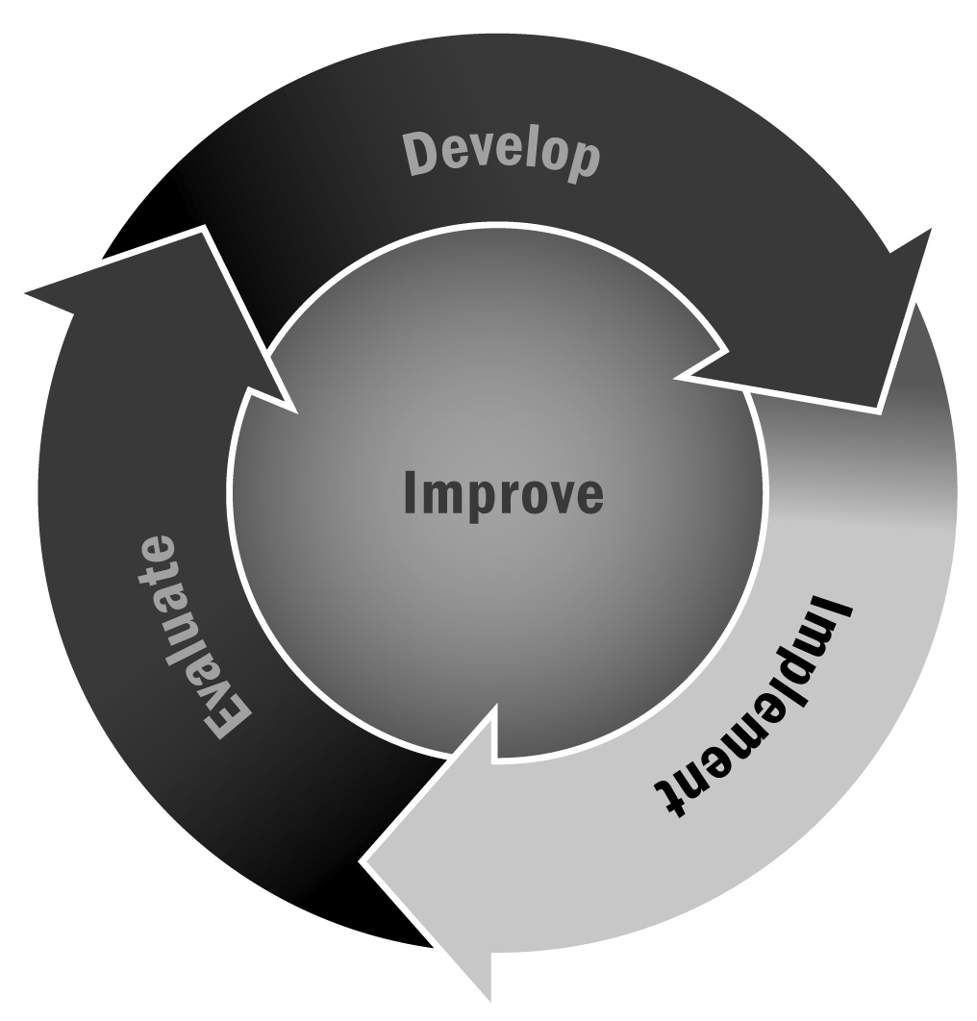
In Chapters 2 and 4, you learned that being intentional in the delivery of afterschool and expanded learning activities means selecting age-appropriate activities, making consistent and fair rules, developing lesson plans with clear goals and intended youth outcomes, and including reflection as a key component of activities. When activities are intentional, youth will experience more positive outcomes (e.g., improved academic success, communication, and skill development).
Directions: In the left column, list the activities (e.g., academic enrichment, games, tutoring/homework help, physical activity) or project (e.g., mural, science, garden, service learning) offered by your program. In the middle column, list the rationale for the activity (e.g., youth interests, community needs, learning, or even fun).
Finally, in the right column indicate how the activity will help participants achieve positive outcomes.

Activity or Project | Rationale for This Activity  (e.g., to support youth learning, to apply academics to the real world, to experience learning) | Intentional Outcomes for Youth  (e.g., social skills, positive development, emotional competencies)
Example: Public Mural Project | 1. Apply academics to real world  2. Community development  3. Decision-making (what to paint based on  the strengths in the community)  4. Exercise youth voice | 1. Math (graphing)  2. Sense of belonging  3. Research and leadership skills  4. Youth voices heard in the community
 | 1.  2.  3.  4. | 1.  2.  3.  4.
 | 1.  2.  3.  4. | 1.  2.  3.  4.
 | 1.  2.  3.  4. | 1.  2.  3.  4.

