61

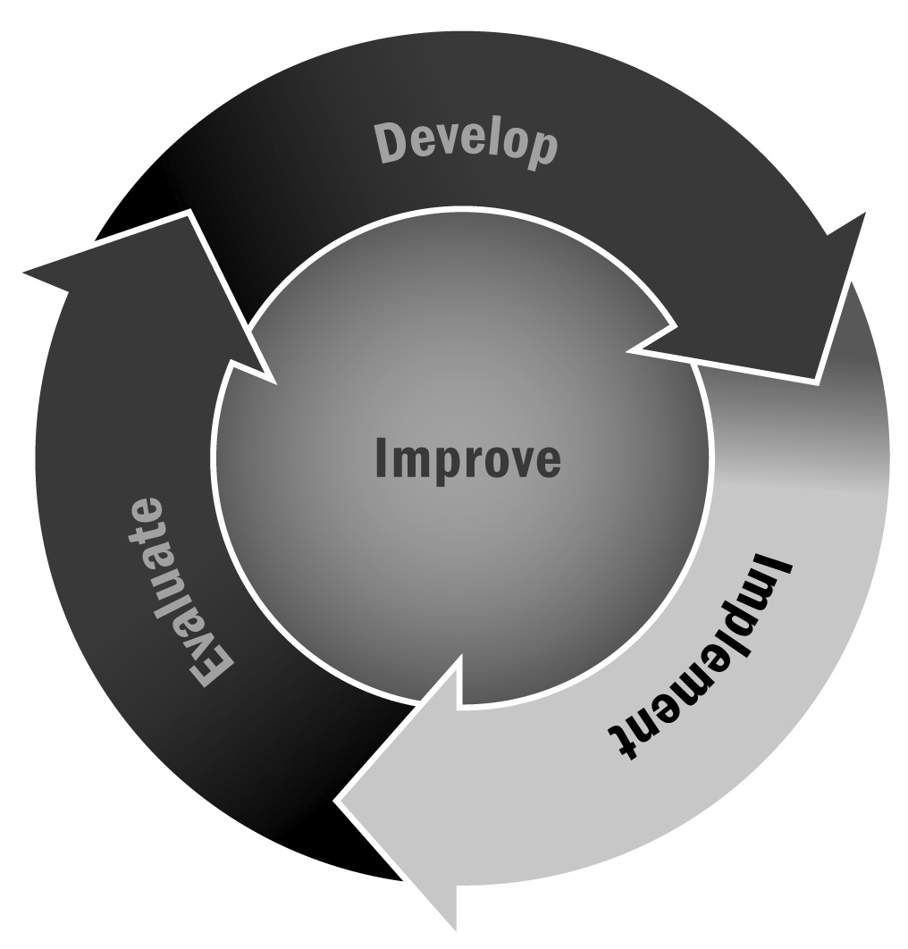
Community Connections
In Chapter 3, you learned about the importance of involving the community in your program. Thinking about where you and your staff might already have connections is a great place to start the process for these partnerships.
Directions: Using Tools 15 and 34, you should have already created an asset map and a market analysis, identifying potential resources in your community that may contribute to your program. Take those tools out now as you begin to work with this tool. While those tools helped you identify organizations, this tool is designed to help you think about the specific connections you want to make to your community and which organizations can help you do that.
Use the list of organizations and resources in your community you have already identified through other tools and fill them in under the categories below to identify how potential partners can benefit your organization or make connections that will benefit your participants. You are provided with a starting point for each category.

Community Connections for Partnerships
- Population diversity — Start with community and heritage organizations.
Community Organizations:

- Cultural traditions — Start with local museums, cultural centers, and historical societies.
Community Organizations:

- Schools — Start with school boards, school administration, principals, and parent-teacher organizations.
Community Organizations:

- Educational exchange organizations — Start with AFS Intercultural Programs, American Institute For Foreign Study (AIFS), American Councils, EF Education First, and others that have networks throughout the country. The Council on Standards for International Educational Travel (CSIET) maintains a list of K–12 travel and study programs at http://www.csiet.org/publications-resources/publications/listed-programs.html.
Community Organizations:

- Colleges and universities — Start with local education programs, faculty, and students, as well as the 120 federally funded (Title VI) university-based National Resource Centers focusing on Africa, Asia, Canada, Europe, Latin America, the Middle East, the Pacific Islands, and international studies. The Outreach World website (http://www.outreachworld.org) highlights various K–12 teaching resources and educational activities produced by the National Resource Centers, beginning with the Middle East.
Community Organizations:

- Business, economic development, and trade organizations — Start with the chamber of commerce or World Trade Council.
Community Organizations:

- Policy centers — Start with state and national government representatives’ offices and websites.
Community Organizations:

- International affairs organizations — Start with the World Affairs Councils of America, United Nations Association and Model United Nations, and state geographic alliances.
Community Organizations:

- Faith-based programs — Start with local churches, temples, mosques, and other houses of worship.
Community Organizations:

- International volunteer programs — Start with Kiwanis, Rotary Clubs, Lions Clubs, and other international humanitarian organizations.
Community Organizations:

- Media — Start with local print, Internet, media, television, and radio stations, especially those whose audiences include diverse cultural groups. International education organizations, such as the International Education and Resource Network (iEARN) and ePals, also provide electronic linkages globally.
Community Organizations:

Personal Connections for Partnerships
Consider the many connections that you and your staff already have that can support your program:
- Heritage — Where in the world do your and your staff members’ families live, and where have they lived in the past?
Notes:
- Community connections — What connections do you and your staff have to the community? (Think about religious groups, membership organizations, former employment, and community groups.)
Notes:

- Culture — What are your or your staff members’ musical and artistic talents, or other cultural connections?
Notes:

- Travel — What experiences have you or your staff had traveling, moving, or migrating? (Consider armchair and virtual travel as well.)
Notes:

- Language — What languages do you and your staff speak, and how have you learned them?
Notes:

- Education — What areas of interest have you and your staff pursued through school or personal study, such as current affairs, historical knowledge, or scientific research?
Notes:

- Employment — Where have you and your staff worked in the past? What industries or professional experience can they share with the program?
Notes:
Now What? Once you have identified the organizations and connections that you can make, compare this list to the list of organizations you identified in Tool 58: Identifying Potential Partnerships. Look for commonalities. If there are four or five organizations that show up on both lists, those are the best places to start. Reach out to those organizations. Ask for a meeting. Talk to them about how you see them as a potential asset to your program. Let them know how you think the program can benefit them. Begin to establish a potential partnership, and use some of the other tools in this section to help you think through strong partnership plans.

