59

Rating Worksheet for Potential Vendor Services
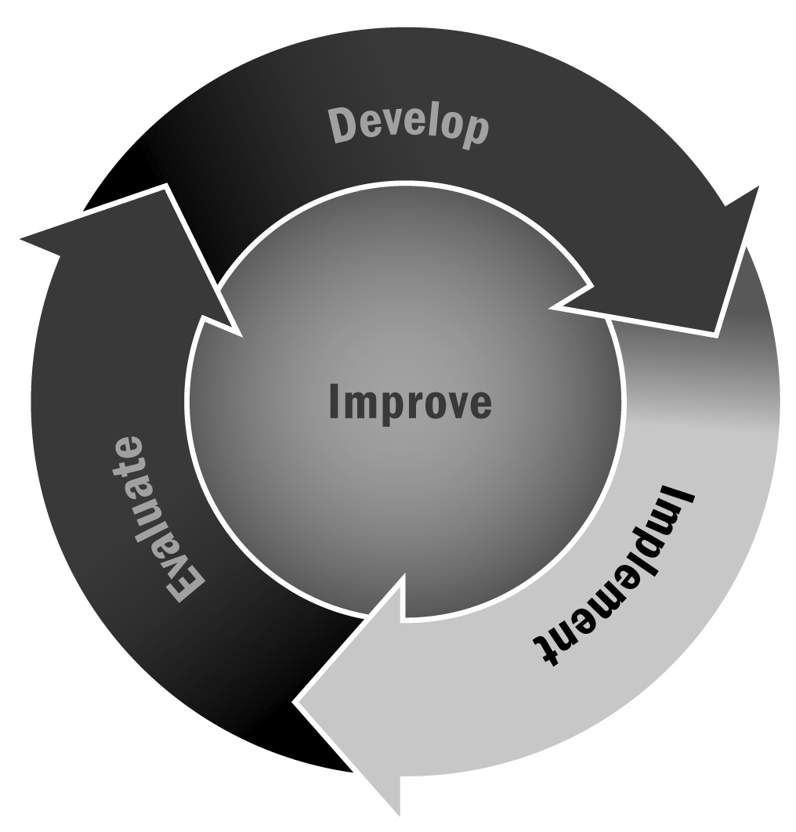
In Chapter 3, you learned that many afterschool and expanded learning programs work with external vendors to provide program activities, workshops, and services. Properly vetting the vendors will ensure a high level of quality in the activities that are offered.
Directions: Before meeting with external vendors, discuss each question below with your staff and advisory board and record the answers. By articulating your expectations, you will be better prepared to question and negotiate with the vendors. After interviewing each vendor, use the rating scale on the last page of this tool to rate how well the vendor meets your expectations for each question. Use the rating page in your final review of vendors and to make a selection.

Category I: Results, Philosophy, Services, and Materials
- What evidence of success (e.g., independent studies, school testimonials) does the vendor possess?
Notes:
- What are the main components of our program approach that we would like the vendor’s program to support?
Notes:
- Which district or state standards should the vendor’s program address?
Notes:
- What types of materials (e.g., books, teacher guides) do we want the vendor to provide? What about specific materials to support all learners (e.g., texts in various languages, large print, audiotapes)?
Notes:
- Do we want a program that incorporates technology? What kind? How should it be used?
Notes:
- What degree of instructor expertise do we want the program to require (e.g., will our program staff members need to have college degrees to effectively deliver the program?)?
Notes:
- How much and what type of training do we want the vendor to provide?
Notes:
- How much and what type of technical assistance (e.g., on-site consulting, conference calls, email exchanges) do we want the vendor to provide?
Notes:

Category II: Expected or Preferred Outcomes
- What outcomes (e.g., increased participation, positive attitude toward learning, academic success, decision-making skills) do we expect for youth after one year? After three years?
Notes:

Category III: Programs Costs
- How much can we afford to spend on an external program vendor? Ideally, how much would we like to spend?
Notes:
- Do we want the vendor to support sustainability or embedding of the program after initial training, purchase of program materials, and support?
Notes:

Vendor Review Checklist
Directions: Complete one checklist for each vendor for which you are considering using the criteria or preferred characteristics identified above. Review the total score for each vendor. The vendor with the highest score is likely the best match for your priorities. However, you might want to weigh certain priorities more than others as you review your total scores.
Rating Scale
4 This vendor fully meets our expectations or preferred characteristics in this area.
3 This vendor meets most of our expectations or preferred characteristics in this area.
2 This vendor meets some of our expectations or preferred characteristics in this area.
1 This vendor does not meet our expectations or preferred characteristics in this area.
 | 4 | 3 | 2 | 1
Evidence of success | ❒ | ❒ | ❒ | ❒
Support for program approach | ❒ | ❒ | ❒ | ❒
Alignment with state standards | ❒ | ❒ | ❒ | ❒
Program materials | ❒ | ❒ | ❒ | ❒
Use of technology | ❒ | ❒ | ❒ | ❒
Expertise required of instructors | ❒ | ❒ | ❒ | ❒
Training | ❒ | ❒ | ❒ | ❒
Technical assistance | ❒ | ❒ | ❒ | ❒
Expected academic outcomes | ❒ | ❒ | ❒ | ❒
Expected non-academic outcomes | ❒ | ❒ | ❒ | ❒
Cost | ❒ | ❒ | ❒ | ❒
Sustainability | ❒ | ❒ | ❒ | ❒
Total Score:

