57

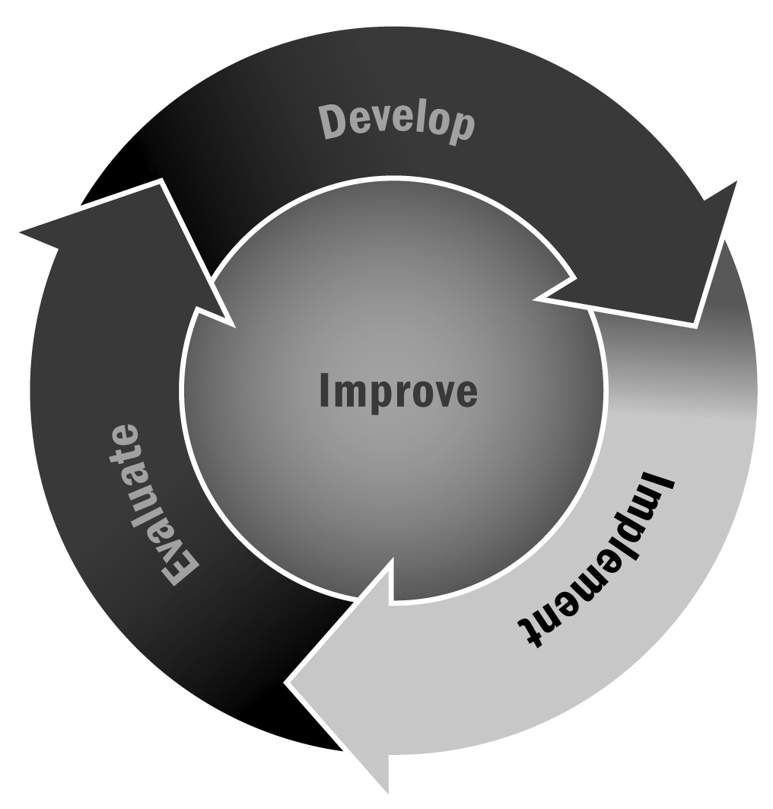
Template for Introductory Communication With Families
In Chapter 3, you learned that ongoing communication between the program and families is probably the most important factor in getting families involved and keeping them involved. Setting up a meeting to discuss how your program can support the community is an important first step in forming a successful and ongoing relationship.
Directions: Use this template to communicate with families in your community about your program.

Tips for Written Communication
- Adapt and adjust all communication for your specific program and the person with whom you are communicating. Personalize whenever possible—refer to how you know the person, ask about something in his or her life, or simply wish the person well!
- Alter the format of your communication to fit the method you are using to communicate.
- If you are sending an email, for example, make sure your subject line clearly identifies the purpose of your email. An email that says “ABC Afterschool Program: Update and Meeting Request” is much more informative and likely to get the attention of your recipient than “ABC Afterschool Program.”
- Make sure your contact information is always included in your email signature.
- If you are sending a letter or memo, be sure to include the date, and always sign your name at the bottom.
- If you are communicating via letter or a printed memo, use your program’s letterhead. If you do not have letterhead, use brightly colored paper.
- Remember to proofread and to follow up your letter, memo, email, or other written communication with a personal phone call. Taking a little extra time can go a long way.
Dear Families,
I want to introduce myself and [name of program]. The vision and goals of our program are to [describe vision and goals].
I’d like to set up some time to meet with you or your representative to discuss how we may further support the school. The following are a list of dates and times that work for me [list dates and times].
Please let me know if any of these work for you.
I look forward to meeting with you and working together to ensure the youth at [school name] are able to participate in our full range of afterschool and expanded learning activities.
Sincerely,
[Your name, address, telephone number, and email address]

