47

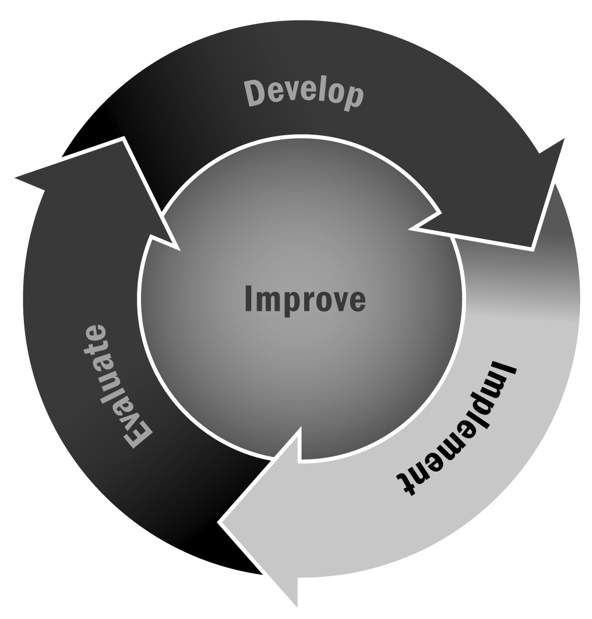
Template for Communicating With School Staff
In Chapter 3, you learned that it is important to connect with the staff members in the school or schools your participants attend. Keeping everyone in the loop will help you maintain a positive relationship with school personnel.
Directions: Use the template on the following page when communicating with school staff members. Adapt this template for your specific topic. Some areas you may wish to communicate about with school staff members include program and school events, data sharing, space and resource allocation, field trips (see Tool 51: Template for Field Trip Planning and Communication With School Staff Members), and success stories.

Tips for Written Communication
- Adapt and adjust all communication for your specific program and the person with whom you are communicating. Personalize whenever possible—refer to how you know the person, ask about something in his or her life, or simply wish the person well!
- Alter the format of your communication to fit the method you are using to communicate.
- If you are sending an email, for example, make sure your subject line clearly identifies the purpose of your email. An email that says “ABC Afterschool Program: Upcoming Events” is much more informative and likely to get the attention of your recipient than “ABC Afterschool Program.”
- Make sure your contact information is always included in your email signature.
- If you are sending a letter or memo, be sure to include the date, and always sign your name at the bottom.
- If you are communicating via letter or a printed memo, use your program’s letterhead. If you do not have letterhead, use brightly colored paper.
- Remember to proofread, and to follow up your letter, memo, email, or other written communication with a personal phone call. Taking a little extra time can go a long way.

Dear [fill in the blank with one of the following: Teacher, School Nurse, School Counselor, Kitchen Staff, Custodian, Principal, or other],
Here is some timely information that you should know about our afterschool and expanded learning program:
OR
I’m happy to share the following information with you:
OR
Just want to keep you posted on the following developments in our afterschool and expanded learning program:
[Add your information here. Be sure to keep it to just two or three sentences; people are more likely to read something that is short and concise.]
Please let me know if you would like more information or if you have a suggestion about something we can do to improve our program.

Sincerely,

[Your name, address, telephone number, and email address]

