32

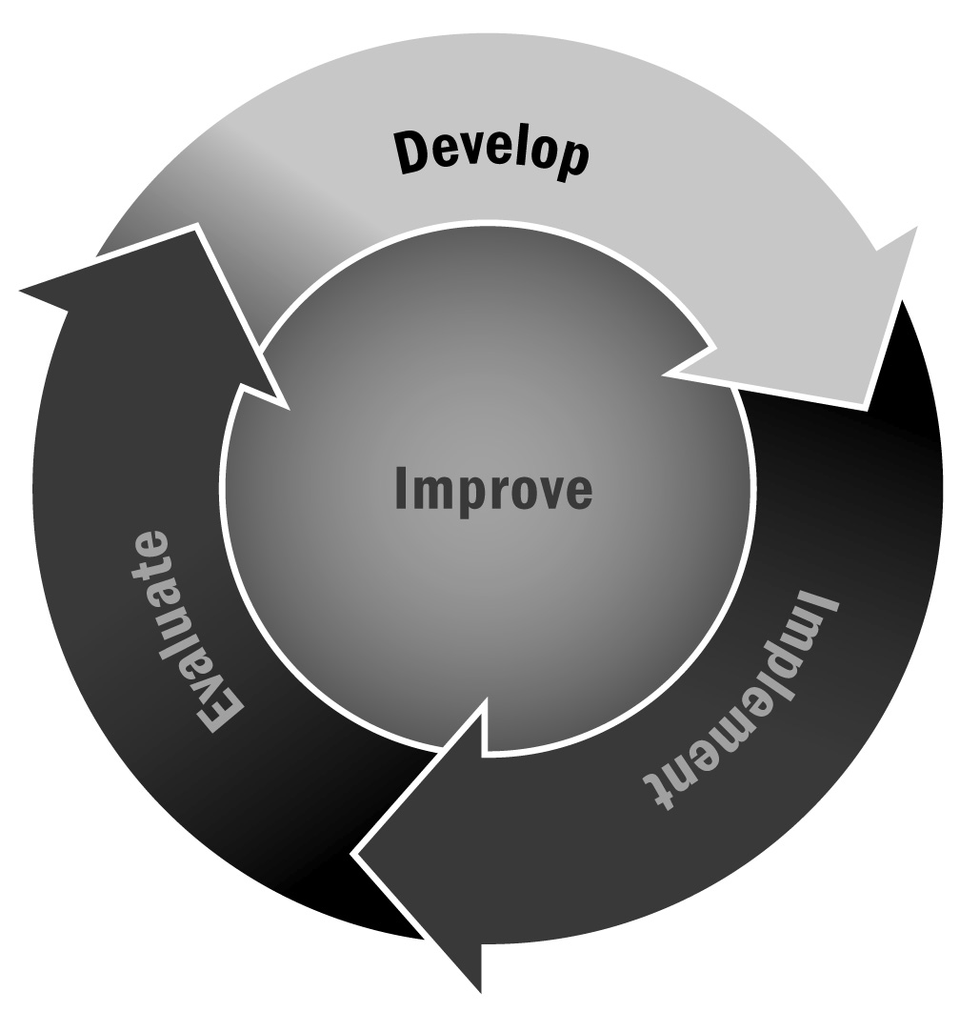
Sample News Release
In Chapter 1, you learned that building relationships with the media is a useful mechanism for getting the word out about your program.
Directions: This tool shows the basic format and elements of a news release. Make sure you include your program name and contact information, and then include a few paragraphs on the news you want to share and distribute it to your local news media outlets. A template and an example news release are provided.

News Release Template
FOR IMMEDIATE RELEASE: [Date]

CONTACT: [First and Last Name], [Role]
[Program Name]
[Phone Number]
[Email Address]
[Program Website Address]

Title of News Release
Lead Paragraph: Who, What, When, Where, Why
Second Paragraph: Quote from organizational spokesperson
Third Paragraph: More information about the announcement
Fourth Paragraph: More information and examples
Fifth Paragraph: Second quote from another organizational spokesperson
Sixth Paragraph: Contact information for the organization

News Release Example
FOR IMMEDIATE RELEASE: August 15, 2013

CONTACT: Jane Project Director
Anytown Afterschool Program
123-456-7890, Ext. 123
jane@anytown.net
http://www.anytownafterschool.net

Anytown Afterschool Program Launches Student-Created Website
ANYTOWN, U.S.A.—The Anytown Afterschool Program, which serves 200 9th- through 12th-graders
in the Anytown Unified School District, has launched its youth-designed website, at http://www.anytownafterschool.net. The website details program news, provides contact and registration information for the program, and highlights the work of young people in the program. It also links to the school website and to the websites of organizations in the community that partner with program, including the Anytown Y, Anytown Medical Center, Anytown Widget Company, and the Anytown Players.
Youth in the program worked on the project for several months with the help of Bill Web and Julie Techno of the Anytown Widget Company Technology Department. When asked what it was like to work with 30 high school youth, Web said, “It was a great experience. I learned as much from the kids as they learned from me.” Techno added, “That’s right. The kids were not afraid to try new and creative graphics, and as a result, they’ve got an informative website that’s also terrific to look at.”
The Anytown Afterschool Program operates from 3:00 p.m. to 6:30 p.m., five days a week, in the Anytown High School. John Principal at Anytown High has reported that youth who participate in the program have improved their leadership skills and increased school day attendance by 15 percent over those who do not participate in the program.
“Youth love the program,” Principal said. “This website shows how much enthusiasm they have and how much they are able to contribute.” Jane Project Director concluded, “The Anytown Afterschool Program is always looking for community partners who can help us create fun and interesting activities in partnership with our participants. Now, the Anytown community can check out our site and contact us if they have any ideas.”
For additional information on the Anytown Afterschool Program or details on how you can help out, visit the website at http://www.anytownafterschool.net or call 222-555-4953, Ext. 328.

