30

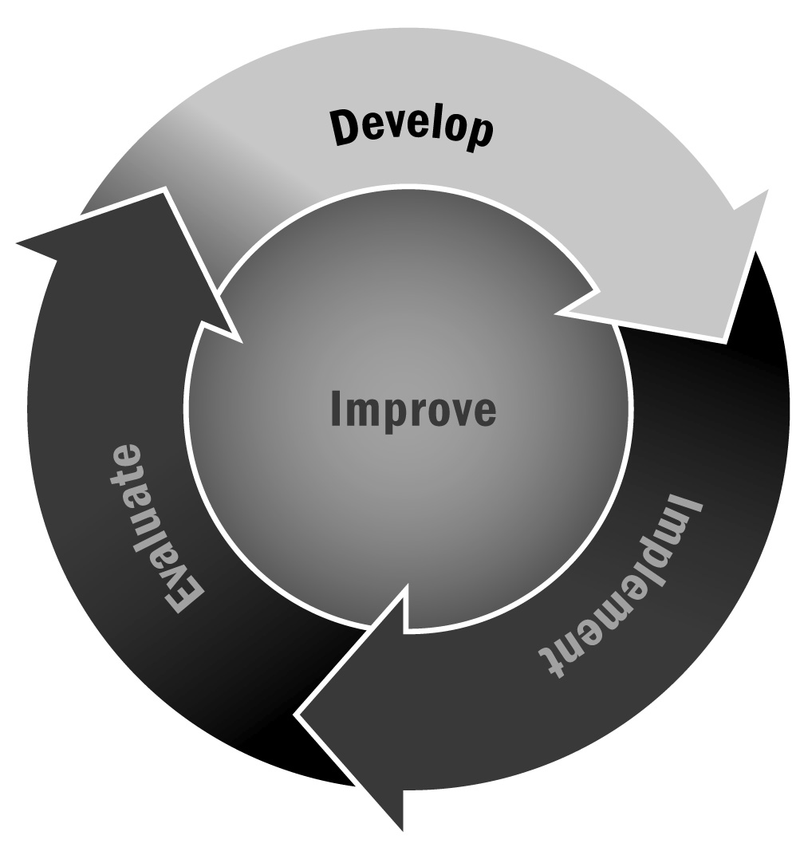
Communication Log
In Chapter 1, you learned that a communication strategy can promote effective and comprehensive two-way communication with program stakeholders. Tracking your communication can be useful both for monitoring communication efforts and for evaluating the effectiveness of that communication.
Directions: There are many different ways to monitor and track your program communication. Using the template on the following page, you can create a log, like the example below, to keep track of your communication efforts in chronological order. Another strategy for tracking communication in your program is to use a notebook stored in a place that is accessible to all staff members. Each staff member can add a note to the log whenever the communication occurs, bearing in mind the following categories: date, audience, content/format, objective, results, and feedback.
Under “Objective,” include what you were hoping to achieve through that particular communication. Under “Result,” include things like attendance levels at meetings, the number of new volunteers, the number of returned surveys, greater adherence to a particular policy, a more cordial relationship with the group, or positive feedback from recipients. Over time, you will be able to see which communication efforts yield better results, and you can use this information to improve your communication strategies.

Communication Log – Example
Date | Audience | Content/Format | Objective | Result | Feedback
5/23/13 | Families of Elm Street School Youth | Radio ad on WACL about upcoming car wash fundraiser | To persuade people to come to the car wash | Bigger turnout than last year | Some families liked that we used youth in the radio ad; other families said that the remaining youth felt left out as a result.
6/19/13 | Families of Elm Street School Youth | Flyers (in English and Spanish) sent home with youth about program-sponsored booth at Fourth of July carnival | To let families know about the carnival and to request adult volunteers for the booth | 20 parents volunteered to staff the booth; more families of participants attended than last year | Several parents asked to be involved in planning the booth next year.

Communication Log – Template
Date | Audience | Content/Format | Objective | Result | Feedback

